# VISVESVARAYA TECHNOLOGICAL UNIVERSITY

## BELAGAVI – 590018, Karnataka INTERNSHIP REPORT

#### ON

“E-Commerce Website to Sell Gym Essentials”

***Submitted in partial fulfilment for the award of degree (18EC185)***

## BACHELOR OF ENGINEERING IN

## ELECTRONICS AND COMMUNICATIONS

***Submitted by:***

#### KIRAN KUMAR S

#### 1SK20EC409



Conducted at

**VARCONS TECHNOLOGIES**



# Govt S. K. S. J. TECHNOLOGICAL INSTITUTE

# Department of Electronics and Communications Accredited by NBA, New Delhi

# K. R. Circle, Bengaluru-560001

# Govt S. K. S. J. TECHNOLOGICAL INSTITUTE

# Department of Electronics and Communications Accredited by NBA, New Delhi

# K. R. Circle, Bengaluru-560001



**CERTIFICATE**

This is to certify that the Internship titled **“E-Commerce Website to Sell Gym Essentials”** carried out by **Mr. KIRAN KUMAR S** a bonafide student of **Govt.S.K.S.J.Technological Institute, Bengaluru**, in partial fulfillment for the award of **Bachelor of Engineering**, in **ELECTRONICS AND COMMUNICATIONS** under **Visvesvaraya Technological University**, Belagavi, during the year 2022-2023. It is certified that all corrections/suggestions indicated have been incorporated in the report.

The project report has been approved as it satisfies the academic requirements in respect of Internship prescribed for the course Internship / Professional Practice (18EC185)

#### Signature of Guide Signature of HOD Signature of Principal

#### 

#### 

**External Viva:**

Name of the Examiner Signature with Date

1)

2)

# D E C L A R A T I O N

I, **KIRAN KUMAR S**, final year student of Electronics and Communicationsbranch, Govt.S.K.S.J.Technological Institute, Bengaluru-560 001, declare that the Internship has been successfully completed, in **Varcons Technologies**. This report is submitted in partial fulfillment of the requirements for award of Bachelor Degree in Electronics and Communications Engineering, during the academic year 2022-2023.

Date : 27/02/2023 :

Place : Bengaluru

USN: 1SK20EC409

NAME: KIRAN KUMAR S

**OFFER LETTER PROVIDED BY THE COMPANY**

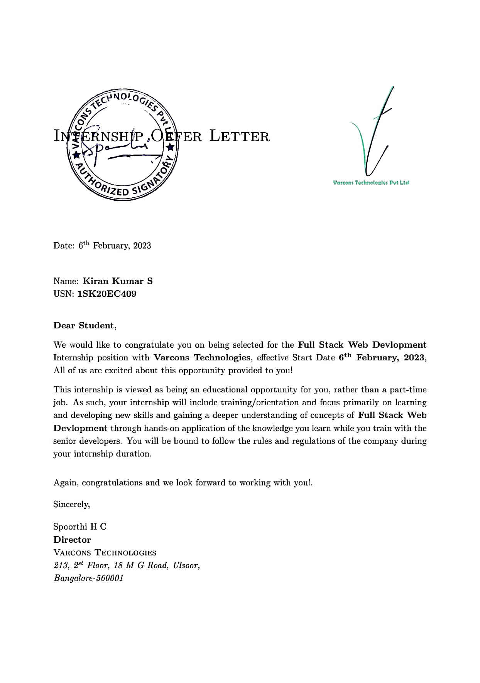

# A C K N O W L E D G E M E N T

This Internship is a result of accumulated guidance, direction and support of several important persons. I take this opportunity to express my gratitude to all who have helped me to complete the Internship.

We express our sincere thanks to our Principal, **Dr. Chandrasekhar K G** for providing us adequate facilities to undertake this Internship.

We would like to thank our **Dr. Nagesh R** Head of Dept., Electronics and Communications for providing us an opportunity to carry out Internship and for his valuable guidance and support.

We are also grateful to our guide, **Dr. N SATHISHA**, Professor Department of Electronics and Communication Engineering, I am extremely thankful and indebted to him for sharing expertise, and sincere and valuable guidance and encouragement extended to me to completing the internship.

We would like to thank all the faculty members of our department for the support extended during the course of Internship.

We would like to thank the non-teaching members of our Electronics and Communications dept., for helping us during the Internship.

Last but not the least, we would like to thank our parents and friends without whose constant help, the completion of Internship would have not been possible.

**KIRAN KUMAR S**

**1SK20EC409**

# ABSTRACT

The project aims to create an e-commerce website that specializes in selling gym essentials, providing customers with convenience, competitive pricing, and a wide selection of products. The website will feature various payment and delivery options, including cash on delivery and door-to-door delivery, to enhance customer experience and satisfaction.

The website will offer a wide range of products, including gym apparel, gym equipment, and supplements, to cater to the needs and preferences of different types of customers. The products will be sourced from reliable and reputable suppliers to ensure quality and authenticity.

Marketing and customer engagement strategies will be implemented to increase website traffic, sales, and revenue. Social media platforms such as Facebook, Instagram, and Twitter will be utilized to showcase products, offer promotions, and engage with customers. Content marketing strategies such as blogs, videos, and tutorials will provide customers with valuable information about products and fitness, enhancing customer experience and loyalty. Customer service strategies such as live chat, email support, and returns and refunds policies will also enhance customer satisfaction and trust.

The success of the project will be measured by the website's traffic, sales, and revenue, as well as customer satisfaction and feedback. Continuous improvements and updates will be made based on customer feedback and market trends to ensure the website remains relevant and competitive in the ever-evolving e-commerce landscape.

# Table of Contents

|  |  |  |
| --- | --- | --- |
| **Sl no** | **Description** | **Page no** |
| 1 | Company Profile | 8 |
| 2 | About the Company | 10 |
| [3](https://1.bp.blogspot.com/-dODuK8N5h1Q/Wlnyb3V9HFI/AAAAAAAACL4/WxQtCJ1pM5wccDABg4wIrTBUB0vlikXQQCLcBGAs/s1600/poly1.jpg) | Introduction | 14 |
| [4](https://1.bp.blogspot.com/-dODuK8N5h1Q/Wlnyb3V9HFI/AAAAAAAACL4/WxQtCJ1pM5wccDABg4wIrTBUB0vlikXQQCLcBGAs/s1600/poly1.jpg) | System Analysis | 17 |
| [5](https://1.bp.blogspot.com/-dODuK8N5h1Q/Wlnyb3V9HFI/AAAAAAAACL4/WxQtCJ1pM5wccDABg4wIrTBUB0vlikXQQCLcBGAs/s1600/poly1.jpg) | Requirement Analysis | 22 |
| 6 | Design [Analysis](https://4.bp.blogspot.com/-IOOxgPaXMVc/Wlj3LWvcnjI/AAAAAAAACKE/UeTFYvAxDmUDel5UBjdifeWaApB3-dXVgCLcBGAs/s1600/img1.jpg) | 24 |
| 7 | [Implementation](https://4.bp.blogspot.com/-IOOxgPaXMVc/Wlj3LWvcnjI/AAAAAAAACKE/UeTFYvAxDmUDel5UBjdifeWaApB3-dXVgCLcBGAs/s1600/img1.jpg) | 28 |
| 8 | Snapshots | 30 |
| 9 | Conclusion | 34 |
| 10 | References | 36 |

[**CHAPTER**](https://1.bp.blogspot.com/-dODuK8N5h1Q/Wlnyb3V9HFI/AAAAAAAACL4/WxQtCJ1pM5wccDABg4wIrTBUB0vlikXQQCLcBGAs/s1600/poly1.jpg) **1** **COMPANY PROFILE**

# COMPANY PROFILE

## A Brief History of Varcons Technologies

Varcons Technologies, was incorporated with a goal ”To provide high quality and optimal Technological Solutions to business requirements of our clients”. Every business is a different and has a unique business model and so are the technological requirements. They understand this and hence the solutions provided to these requirements are different as well. They focus on clients requirements and provide them with tailor made technological solutions. They also understand that Reach of their Product to its targeted market or the automation of the existing process into e-client and simple process are the key features that our clients desire from Technological Solution they are looking for and these are the features that we focus on while designing the solutions for their clients.

Sarvamoola Software Services. is a Technology Organization providing solutions for all web design and development, MYSQL, PYTHON Programming, HTML, CSS, ASP.NET and LINQ. Meeting the ever increasing automation requirements, Sarvamoola Software Services. specialize in ERP, Connectivity, SEO Services, Conference Management, effective web promotion and tailor-made software products, designing solutions best suiting clients requirements.

Varcons Technologies, strive to be the front runner in creativity and innovation in software development through their well-researched expertise and establish it as an out of the box software development company in Bangalore, India. As a software development company, they translate this software development expertise into value for their customers through their professional solutions.

They understand that the best desired output can be achieved only by understanding the clients demand better. Varcons Technologies work with their clients and help them to define their exact solution requirement. Sometimes even they wonder that they have completely redefined their solution or new application requirement during the brainstorming session, and here they position themselves as an IT solutions consulting group comprising of high caliber consultants.

They believe that Technology when used properly can help any business to scale and achieve new heights of success. It helps Improve its efficiency, profitability, reliability; to put it in one sentence ” Technology helps you to Delight your Customers” and that is what we want to achieve.

# [CHAPTER](https://1.bp.blogspot.com/-dODuK8N5h1Q/Wlnyb3V9HFI/AAAAAAAACL4/WxQtCJ1pM5wccDABg4wIrTBUB0vlikXQQCLcBGAs/s1600/poly1.jpg) 2 ABOUT THE COMPANY

1. **ABOUT THE COMPANY**



Varcons Technologies is a Technology Organization providing solutions for all web design and development, MYSQL, PYTHON Programming, HTML, CSS, ASP.NET and LINQ. Meeting the ever increasing automation requirements, Varcons Technologies specialize in ERP, Connectivity, SEO Services, Conference Management, effective web promotion and tailor-made software products, designing solutions best suiting clients requirements. The organization where they have a right mix of professionals as a stakeholder to help us serve our clients with best of our capability and with at par industry standards. They have young, enthusiastic, passionate and creative Professionals to develop technological innovations in the field of Mobile technologies, Web applications as well as Business and Enterprise solution. Motto of our organization is to “Collaborate with our clients to provide them with best Technological solution hence creating Good Present and Better Future for our client which will bring a cascading a positive effect in their business shape as well”. Providing a Complete suite of technical solutions is not just our tag line, it is Our Vision for Our Clients and for Us, We strive hard to achieve it.

## Products of Varcons Technologies.

**Android Apps**

It is the process by which new applications are created for devices running the Android operating system. Applications are usually developed in Java (and/or Kotlin; or other such option) programming language using the Android software development kit (SDK), but other development environments are also available, some such as Kotlin support the exact same Android APIs (and bytecode), while others such as Go have restricted API access.

The Android software development kit includes a comprehensive set of development tools. These include a debugger, libraries, a handset emulator based on QEMU, documentation, sample code, and tutorials. Currently supported development platforms include computers running Linux (any modern desktop Linux distribution), Mac OS X 10.5.8 or later, and Windows 7 or later. As of March 2015, the SDK is not available on Android itself, but software development is possible by using specialized Android applications.

**Web Application**

It is a client–server computer program in which the client (including the user interface and client- side logic) runs in a web browser. Common web applications include web mail, online

retail sales, online auctions, wikis, instant messaging services and many other functions. web applications use web documents written in a standard format such as HTML and JavaScript, which are supported by a variety of web browsers. Web applications can be considered as a specific variant of client–server software where the client software is downloaded to the client machine when visiting the relevant web page, using standard procedures such as HTTP. The Client web software updates may happen each time the web page is visited. During the session, the web browser interprets and displays the pages, and acts as the universal client for any web application. The use of web application frameworks can often reduce the number of errors in a program, both by making the code simpler, and by allowing one team to concentrate on the framework while another focuses on a specified use case. In applications which are exposed to constant hacking attempts on the Internet, security- related problems can be caused by errors in the program.

Frameworks can also promote the use of best practices such as GET after POST. There are some who view a web application as a two-tier architecture. This can be a “smart” client that performs all the work and queries a “dumb” server, or a “dumb” client that relies on a “smart” server. The client would handle the presentation tier, the server would have the database (storage tier), and the business logic (application tier) would be on one of them or on both. While this increases the scalability of the applications and separates the display and the database, it still doesn’t allow for true specialization of layers, so most applications will outgrow this model. An emerging strategy for application software companies is to provide web access to software previously distributed as local applications. Depending on the type of application, it may require the development of an entirely different browser-based interface, or merely adapting an existing application to use different presentation technology. These programs allow the user to pay a monthly or yearly fee for use of a software application without having to install it on a local hard drive. A company which follows this strategy is known as an application service provider (ASP), and ASPs are currently receiving much attention in the software industry.

Security breaches on these kinds of applications are a major concern because it can involve both enterprise information and private customer data. Protecting these assets is an important part of any web application and there are some key operational areas that must be included in the development process. This includes processes for authentication, authorization, asset handling, input, and logging and auditing. Building security into the applications from the beginning can be more effective and less disruptive in the long run.

**Web design**

It is encompassing many different skills and disciplines in the production and maintenance of websites. The different areas of web design include web graphic design; interface design; authoring, including standardized code and proprietary software; user experience design; and

search engine optimization. The term web design is normally used to describe the design process relating to the front-end (client side) design of a website including writing mark up. Web design partially overlaps web engineering in the broader scope of web development. Web designers are expected to have an awareness of usability and if their role involves creating markup then they are also expected to be up to date with web accessibility guidelines. Web design partially overlaps web engineering in the broader scope of web development.

## Departments and services offered

Varcons Technologies plays an essential role as an institute, the level of education, development of student’s skills are based on their trainers. If you do not have a good mentor then you may lag in many things from others and that is why we at Varcons Technologies gives you the facility of skilled employees so that you do not feel unsecured about the academics. Personality development and academic status are some of those things which lie on mentor’s hands. If you are trained well then you can do well in your future and knowing its importance of Varcons Technologies always tries to give you the best.

They have a great team of skilled mentors who are always ready to direct their trainees in the best possible way they can and to ensure the skills of mentors we held many skill development programs as well so that each and every mentor can develop their own skills with the demands of the companies so that they can prepare a complete packaged trainee.

## Services provided by Varcons Technologies.

* Core Java and Advanced Java
* Web services and development
* Dot Net Framework
* Python
* Selenium Testing
* Conference / Event Management Service
* Academic Project Guidance
* On The Job Training
* Software Training

# [CHAPTER](https://1.bp.blogspot.com/-dODuK8N5h1Q/Wlnyb3V9HFI/AAAAAAAACL4/WxQtCJ1pM5wccDABg4wIrTBUB0vlikXQQCLcBGAs/s1600/poly1.jpg) 3 INTRODUCTION

1. **INTRODUCTION**

## Introduction to Web Apps

Web applications are similar to the traditional applications you’d install on your Information, such as Microsoft Office. They are able to perform the same kinds of tasks, they look the same and they feel the same but there is one key difference - the application itself is not installed on your phone or Information, but lives in the cloud. Web apps are not new, but it used to be that they were often unable to compete with more traditional applications for business critical functions or where rich user interaction was required. This is no longer the case. With the power of modern web technologies, we are able to design and build performing, secure, and feature rich applications that live in the cloud and bring with them a huge number of benefits.

#### They can be accessed from anywhere.

* Because web applications are built with web technologies and they run in a web browser Internet Explorer, Google Chrome, Mozilla Firefox – this allows them to be accessed from every web enabled tool. As long as you have an internet connection you can use them.
* It allows for remote working, it allows for rapid publishing of content, it allows for real time collaboration between teams. If you have web access, you have the ability to access your business tools.

#### They are cost effective.

* Web applications are cheaper to produce and maintain than traditional applications. No matter how many platforms your business uses (Mac, Linux, Windows) web application build can be used across them all.

#### They benefit from more rapid update cycles.

* A huge benefit of web applications is that when an update is released, all of your users are immediately using that version. This doesn’t happen with installed applications, especially in large organizations with IT policies that restrict administrator access.

#### They are secure.

* Web developers have had to become experts in security – the web is a platform designed to share everything with everyone! As such, the types and levels of security included in web applications are often far greater than those seen in traditional applications.
* They also benefit from the ability to launch updates in real-time – the application on the servers is the application people are using. The applications on people’s laptops however is the version last installed. And when those laptops get left on a train it’s not a concern, as nothing is stored locally.

#### They enable more computing with fewer Information.

* Web applications push all of the hard work to the servers, and act as intermediaries between the user interface and the calculations happening behind the scenes. This means you can accomplish terrifyingly complex work on a tablet, or your phone.
* We’ve built web applications that allow people to understand the complex relationships between 250,000 pieces of art on their phones, and applications that run the business systems of one of the largest solar energy providers in the world. Often these products are not financially viable to build using traditional application processes.

## Problem Statement

Develop an application which facilitates creation of web pages having a need to install any HTML editor based software and also which can be used by any novice user (no HTML knowledge needed) that is developing web pages on the online. This module is designed to reduce the process involved in managing the activity of customers and business where the business can sell their services and the customers can buy those.

## Introduction to B2C Ecommerce Website Development with Admin Panel

B2C E-commerce website content providers to focus on creating effective assessment questions and focusing on providing a platform for easy access between Buyer and Consumer.

Here we present techniques that are pertinent to the elements of assessment process: answers submission, Informationized grading, and feedback after submission. As the modern organizations are automated and Information are working as per the instructions, it becomes essential for the coordination of human beings, commodity and Information in a modern

organization.

[**CHAPTER**](https://1.bp.blogspot.com/-dODuK8N5h1Q/Wlnyb3V9HFI/AAAAAAAACL4/WxQtCJ1pM5wccDABg4wIrTBUB0vlikXQQCLcBGAs/s1600/poly1.jpg) **4**

**SYSTEM ANALYSIS**

**4. SYSTEM ANALYSIS**

**System Analysis** refers into the process of examining a situation with the intent of improving it through better procedures and methods. System Analysis is the process of planning a new System to either replace or complement an existing system. But before any planning is done the old system must be thoroughly understood and the requirements determined. System Analysis, is therefore, the process of gathering and interpreting facts, diagnosing problems and using the information to re-comment improvements in the System. Or in other words, System Analysis means a detailed explanation or description. Before computerized a system under consideration, it has to be analyzed. We need to study how it functions currently, what are the problems, and what are the requirements that the proposed system should meet.

**System Analysis is conducted with the following objectives in mind:**

1. Identify the customer’s need.
2. Evaluate the system concept for feasibility.
3. Perform economic and technical analysis.
4. Allocate functions to hardware, software people, database and other system elements.
5. Establish cost and schedule constraints.
6. Create a system definition that forms the foundation for all the subsequent engineering work**.**
   1. **Identification of Customer’s Need**

**Before proceeding further, It becomes very necessary to accumulate the valid and convincing requirements of the project and communicate the very same to various stakeholders of the project.**

This step is initiation of System Analysis. An overview of the client’s requirement has been done. The basic need of the client to opt for such kind of project is analyzed. As per current marketing scenario, an entire system was required to track day-to-day transactions.

Client was following a Manual Process, which is not at all compatible with its current working conditions. It was not only time consuming, but also lacks accuracy. Security point of view the manual system was failed to hide the information from any unauthenticated staff or any outside person. Therefore, there was an urgent requirement of such Computerized System which can fulfill all of its current as well as future requirements. Furthermore, data handling was also posing a serious problem for them.

* 1. **Preliminary Investigation**

The client set is just a worker(s), who is regularly indulged in manual maintenance transactions, keeping regular records, maintaining the records of fine details of members.

Following manual registers are maintained:

* + - **Member’s Details Register:**

This Register is maintained in liu to maintain the records of the various members of the 1-2- Personal Training center. The document contains relevant information about the various members such as members’ id, Name, Address, Telephone number.

* + - **Employee’s Details Register:**

This Register is maintained in Liu to maintain the records of the various employees of the 1-2- Personal Training center. The document contains relevant information about the various employees such as employee’s id, Name, Address, Telephone number.

* + - **Inventory Register:**

The register is used to record the details of the products (supplements, beverages and apparels supplied and required) such as its ID, Description, Quantity, Price, service date, time period for which it is under maintenance etc.

* 1. **Feasibility Study**

Depending on the results of the initial investigation, the survey is expanded to a more detailed feasibility study. Feasibility study is a test of system proposal according to its workability, impact on the organization, ability to meet user needs, and effective use of resources. The objective of the feasibility study is not to solve the problem but to acquire a sense of its scope. During the study, the problem definition is crystallized and aspects of the problem to be included in the system are determined. Consequently, costs and benefits are described with greater accuracy at this stage.

It consists of the following:

1. **Statement of the problem:**

A carefully worded statement of the problem that led to analysis**.**

1. **Summary of finding and recommendations:**

A list of the major findings and recommendations of the study. It is ideal for the user who requires quick access to the results of the analysis of the system under study. Conclusion are stated, followed by a list of the recommendation and a justification for them**.**

1. **Details of findings :**

An outline of the methods and procedure under-taken by the existing system, followed by coverage of the objectives and procedures of the candidate system. Included are also discussions of output reports, file structures, and costs and benefits of the candidate system**.**

1. **Recommendations and conclusions:**

Specific recommendations regarding the candidate system, including personnel assignments, costs, project schedules, and target dates.

* + 1. **Technical Feasibility**

Technical feasibility centers around the existing computer system (Hardware and Software etc.) and to what extend it support the proposed addition. For example, if the current computer is operating at 80 percent capacity - an arbitrary ceiling - then running another application could overload the system or require additional Hardware. This involves financial considerations to accommodate technical enhancements. If the budgets

is a serious constraint, then the project is judged not feasible. In this project, all the necessary cautions have been taken care to make it technically feasible. Using a key the display of text/object is very fast. Also, the tools, operating system and programming language used in this localization process is compatible with the existing one.

* + 1. **Economic Feasibility**

Economic analysis is the most frequently used method for evaluating the effectiveness of the candidate system. More commonly known as cost/benefit analysis, the procedure is to be determining the benefits and savings that are expected from a candidate and compare them with costs. If benefits outweigh costs, then the decision is made to design and implement the system.

A systems financial benefit must exceed the cost of developing that system. i.e. a new system being developed should be a good investment for the organization. Economic feasibility considers the following:

* + - 1. The cost to conduct a full system investigation.
      2. The cost of hardware and software for the class of application.
      3. The benefits in the form of reduced cost or fewer costly errors.
      4. The cost if nothing changes (i.e. The proposed system is not developed).

The proposed SYSTEM is economically feasible because

* + - * 1. The system requires very less time factors.
        2. The system will provide fast and efficient automated environment instead of slow and error prone manual system, thus reducing both time and man power spent in running the system.
        3. The system will have GUI interface and very less user training is required to learn it.
        4. The system will provide service to view various information if required for some decision making.
    1. **Operational Feasibility**

This Application is very easy to operate as it is made user friendly with the help of very effective GUI tools . Main consideration is user’s easy access to all the functionality of the Application. Another main consideration is here is that whether user organization is trained enough to use the newer application. Here every functionality is As per previous operational strategy which is not expected to be cumbersome to the potential clients.

* + 1. **Behavioral Feasibility**

People are inherently resistant to change, and computers have been known to facilitate change. An estimate should be made of how strong a reaction the user staff is likely to have toward the development of a computerized system. Therefore it is understandable that the introduction of a candidate system requires special efforts to educate and train the staff. The software that is being developed is user friendly and easy to learn. In this way, the developed software is truly efficient and can work on any circumstances, tradition, locales.

Behavioral study strives on ensuring that the equilibrium of the organization and status quo in the organization are nor disturbed and changes are readily accepted by the users.

* 1. **Proposed System Functionality**

The proposed system will be designed to support the following features:-

* The proposed system has a **user friendly Interface** for porting of data to server.
* The proposed system provides the facility to pull the data from the server using a key (such as id) and get the desired report.

The proposed system provides the **no replication** of data.

# [CHAPTER](https://1.bp.blogspot.com/-dODuK8N5h1Q/Wlnyb3V9HFI/AAAAAAAACL4/WxQtCJ1pM5wccDABg4wIrTBUB0vlikXQQCLcBGAs/s1600/poly1.jpg) 5 REQUIREMENT ANALYSIS

**5. REQUIREMENT ANALYSIS**

## Hardware Requirement Specification

## Processor: Intel core i5 processer

## Memory: 15.6 GB

## Hard Disk: 40 GB

## Software Requirement Specification

* **Operating System:** Windows or Linux
* **Coding Language:** HTML, CSS
* **Editor:** Visual Studio Code
* **Design Tools:** Figma, TeleportHq
* **Database:** My SQL
* **Testing:** Chrome/ Microsoft Edge Safari

### Non-Functional Requirements

### Availability

The online registration system shall permit backing up of the registration database while other registration actives are going on.

* **Accessibility**

The system shall be accessible by people with specific vision needs to the extent that a user shall be able to display whole user interface in a larger font without truncating displayed text or other values.

* **Security**

The access permissions for system data may only be change by the systems data administrator passwords shall never be viewable at the point of entry or any other time.

# [CHAPTER](https://1.bp.blogspot.com/-dODuK8N5h1Q/Wlnyb3V9HFI/AAAAAAAACL4/WxQtCJ1pM5wccDABg4wIrTBUB0vlikXQQCLcBGAs/s1600/poly1.jpg) 6 DESIGN ANALYSIS

1. **DESIGN & ANALYSIS**

### Theme Design Layout:

The theme used for our project is trending theme which have good layout format. The theme was developed on our own referring some of the websites.

|  |  |  |  |  |
| --- | --- | --- | --- | --- |
| **Logo** | **Search**  **Tab** | **Account SignUp/ LogIn** | **Shopping Cart** | |
| **Menu** | | | |
| **Website Header Section** | | | | **Socials** |
| **Chat Bot** |
| **Featured Products** | | | | **Socials** |
| **Chat Bot** |
| **Categorized Products** | | | | **Socials** |
| **Chat Bot** |
| **Newsletter Subscription** | | | | **Socials** |
| **Chat Bot** |
| **Website Footer Section** | | | | **Socials** |
| **Chat Bot** |
| **Sub-Footer Section** | | | | |

Fig 6.1: Layout of Theme Design\

**6.1.1 Navigation Bar**

Navigation bar is the place where users can go through all the items that are selected from website back-end. Actually, it is a page type of the site. We can create menus. This will bring to the edit menus screen which is divided into two columns. The column on our left has our pages, categories, and custom links tab. The column on the right is where we can add and adjust menu items.

**6.1.2 Slider**

Slider is the part of website that contains image that continuously changes. In this theme, Slider Revolution plugin is used to define slider with proper front- end and back-end tools. Sliders can run slideshows automatically without user input by moving slides on pre-defined time interval.

Sliders can also respond to user interaction like click or swipe to view next or previous slides. Additionally, sliders can also have buttons or thumbnails which users can click to view a particular slide in the slider.

**6.1.3 Sidebar**

Sidebar is the section where recently viewed products, search filter etc. are placed as a shortcut for the content of the site especially for product shop pages. themes to display information that is not a part of the main content. It is not always a vertical column on the side. It can be a horizontal rectangle below or above the content area, footer, header, or anywhere in the file.

**6.1.4 Footer**

The footer area of a website is usually defined in the template file footer.html. In some themes, the area may also contain a widget zed area with multiple columns that you can use.

**ANANLYSIS**

**Introduction To Analysis Unit Testing:**

Unit testing focuses verification effort on the smallest unit of software design that is the module. Using procedural design description as a guide, important control paths are tested to uncover errors within the boundaries of the module. The unit test is normally white box testing oriented and the step can be conducted in parallel for multiple modules.

**6.1.5 Validation Testing**

At the end of integration testing software is completely assembled as a package. Validation testing is the next stage, which can be defined as successful when the software functions in the manner reasonably expected by the customer. Reasonable expectations are those defined in the software requirements specifications. Information contained in those sections form a basis for validation testing approach.

**6.1.6 Integration Testing**

Integration testing is a systematic technique for constructing the program structure, while conducting test to uncover errors associated with the interface. The objective is to take unit tested methods and build a program structure that has been dictated by design.

**6.1.7 Browser Compatibility Testing**

Browser compatibility test is the test done to ensure that site runs on all browsers i.e. chrome, safari etc. these browsers run on different platforms so it is very important ensure that the theme is all platform friendly.

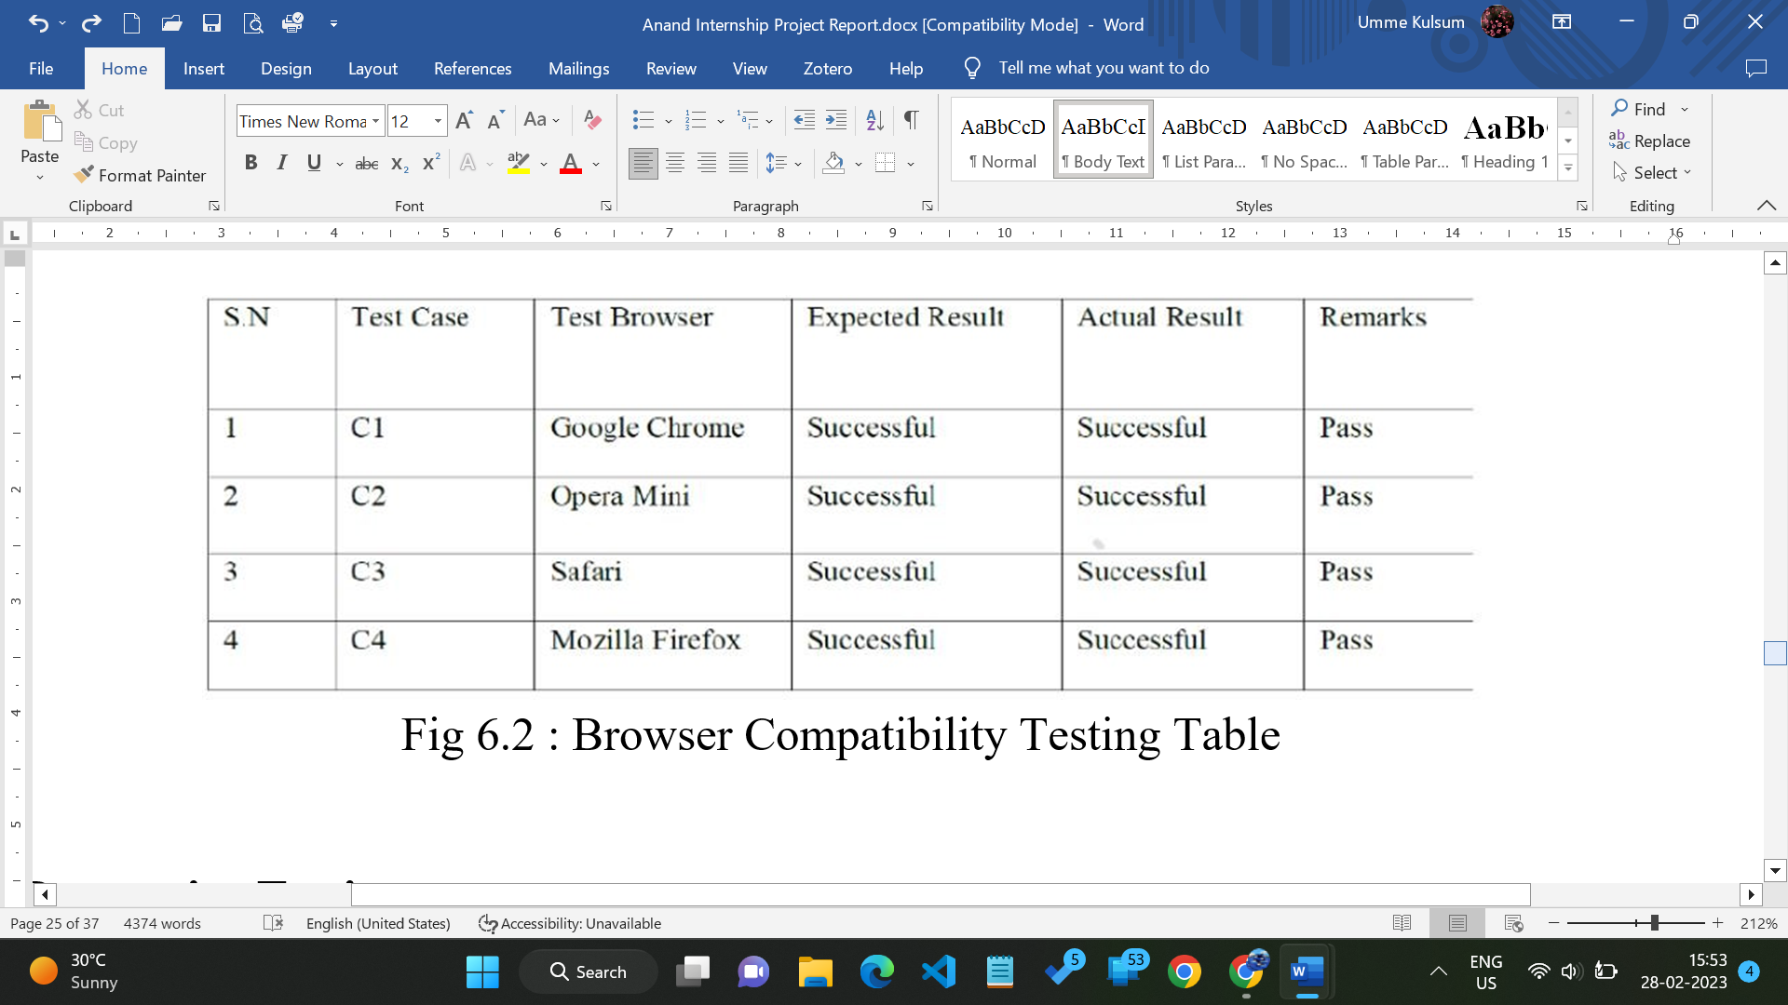

Fig 6.2 : Browser Compatibility Testing Table

**6.1.8 Responsive Testing**

Responsive testing is very important because theme should give majority of the users as they open the site throughout the various devices like laptop, mobiles, tablets etc.

# [CHAPTE](https://1.bp.blogspot.com/-dODuK8N5h1Q/Wlnyb3V9HFI/AAAAAAAACL4/WxQtCJ1pM5wccDABg4wIrTBUB0vlikXQQCLcBGAs/s1600/poly1.jpg)R 7 IMPLEMENTATION

1. **IMPLEMENTATION**

Implementation is the stage where the theoretical design is turned into a working system. The most crucial stage in achieving a new successful system and in giving confidence on the new system for the users that it will work efficiently and effectively.

The system can be implemented only after thorough testing is done and if it is found to work according to the specification. It involves careful planning, investigation of the current system and it constraints on implementation, design of methods to achieve the changeover and an evaluation of change over methods a part from planning.

Two major tasks of preparing the implementation are education and training of the users and testing of the system. The more complex the system being implemented, the more involved will be the system analysis and design effort required just for implementation.

The implementation phase comprises of several activities. The required hardware and software acquisition is carried out. The system may require some software to be developed. For this, programs are written and tested. The user then changes over to his new fully tested system and the old system is discontinued.

## TESTING

The testing phase is an important part of software development. It is the Information zed system will help in automate process of finding errors and missing operations and also a complete verification to determine whether the objectives are met and the user requirements are satisfied. Software testing is carried out in three steps:

1. The first includes unit testing, where in each module is tested to provide its correctness, validity and also determine any missing operations and to verify whether the objectives have been met. Errors are noted down and corrected immediately.
2. Unit testing is the important and major part of the project. So errors are rectified easily in particular module and program clarity is increased. In this project entire system is divided into several modules and is developed individually. So unit testing is conducted to individual modules.
3. The second step includes Integration testing. It need not be the case, the software whose modules when run individually and showing perfect results, will also show perfect results when run as a whole.

# [CHAPTE](https://1.bp.blogspot.com/-dODuK8N5h1Q/Wlnyb3V9HFI/AAAAAAAACL4/WxQtCJ1pM5wccDABg4wIrTBUB0vlikXQQCLcBGAs/s1600/poly1.jpg)R 8 SNAPSHOTS

* 1. **SNAPSHOTS**

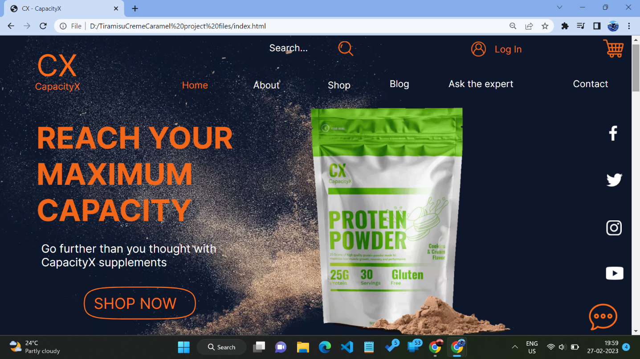

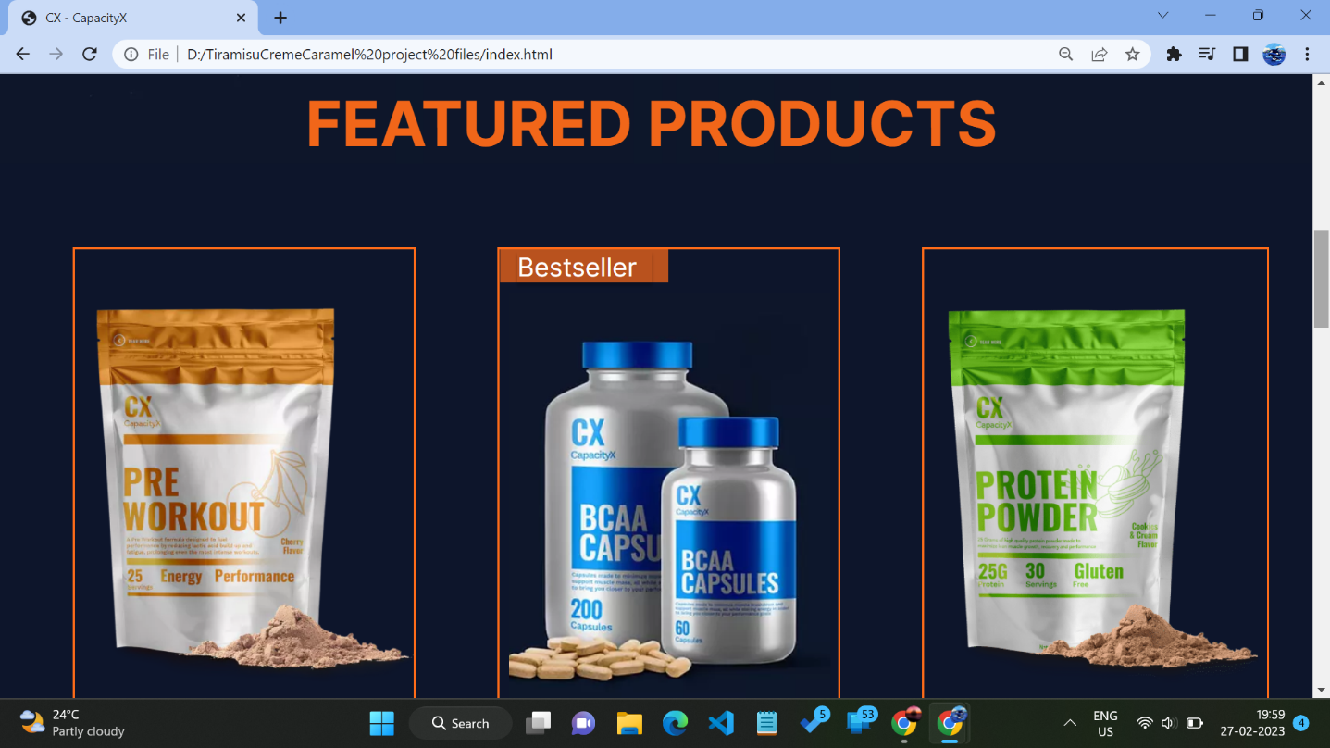

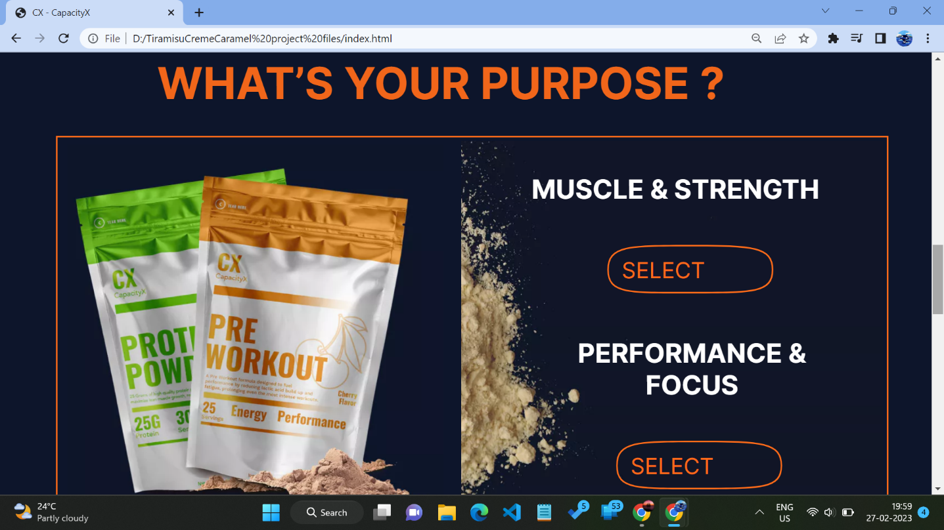

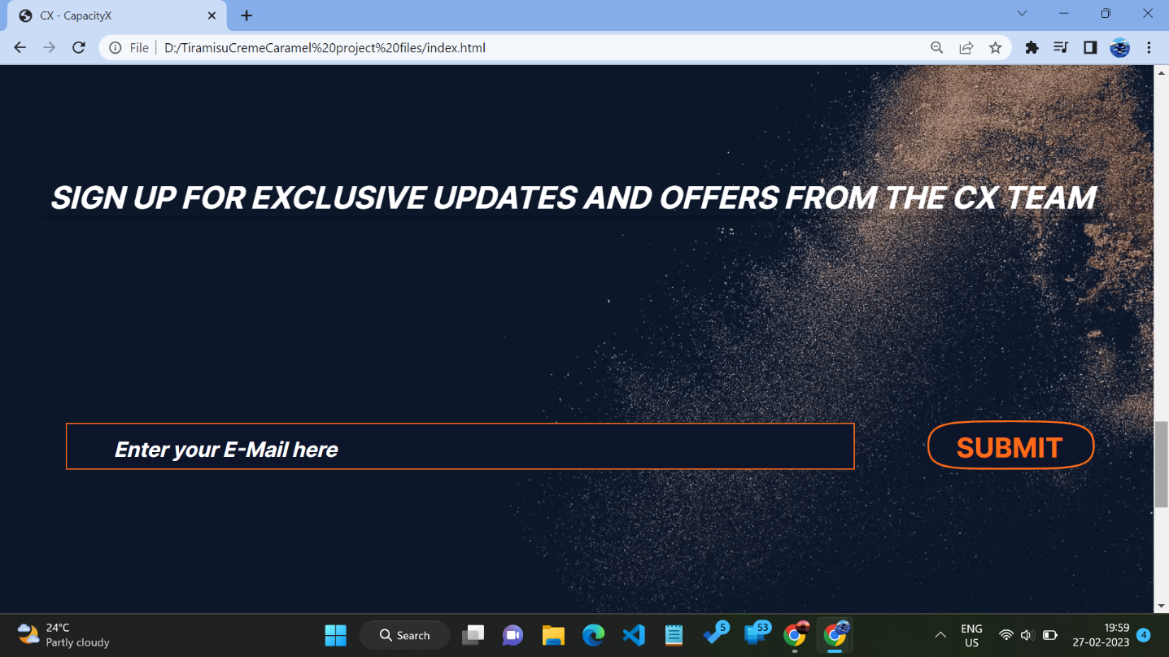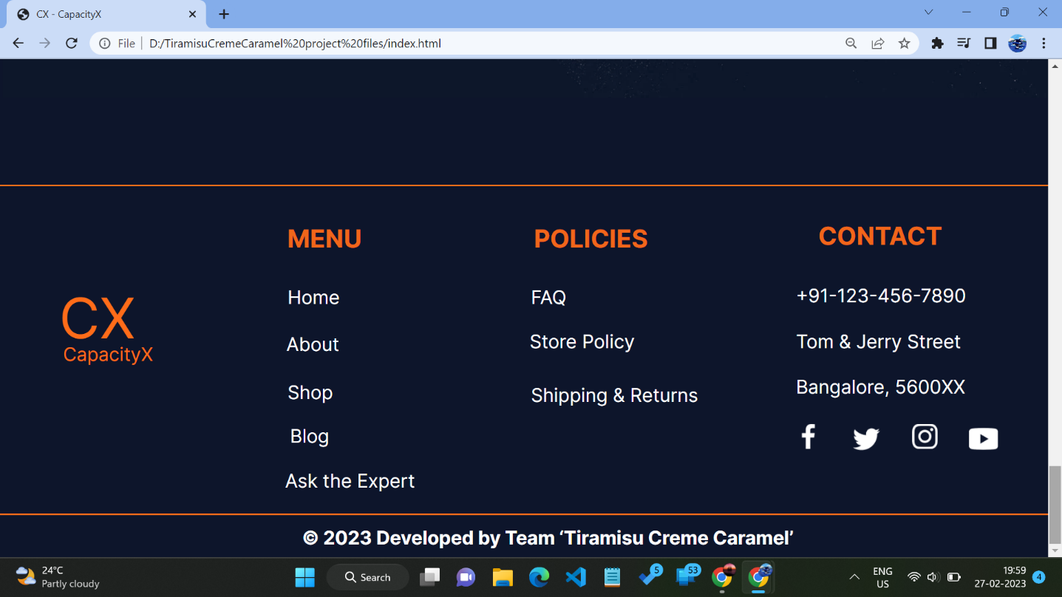

# [CHAPTE](https://1.bp.blogspot.com/-dODuK8N5h1Q/Wlnyb3V9HFI/AAAAAAAACL4/WxQtCJ1pM5wccDABg4wIrTBUB0vlikXQQCLcBGAs/s1600/poly1.jpg)R 9 CONCLUTION

* 1. **CONCLUTION**

The package was designed in such a way that future modifications can be done easily. The following conclusions can be deduced from the development of the project:

* Automation of the entire system improves the efficiency
* It provides a friendly graphical user interface which proves to be better when compared to the existing system.
* It gives appropriate access to the authorized users depending on their permissions.
* It effectively overcomes the delay in communications.
* Updating of information becomes so easier
* System security, data security and reliability are the striking features.
* The System has adequate scope for modification in future if it is necessary.

# REFERENCES

**Book & Authors**

1. Randy Connolly, Ricardo Hoar, "Fundamentals of Web Development”, 1 st Pearson Education India.
2. Robin Nixon, HTML5”, 4 th “Learning PHP, MySQL &JavaScript with jQuery, CSS and Edition, O‟Reilly Publications
3. Luke Welling, Laura Thomson, “PHP and MySQL Web Development”, 5 th Pearson Education, 2016.
4. Nicholas C Zakas, ISBN: 9789332582736) “Professional JavaScript for Web Developers”, Wrox/Wiley India, 2012.
5. David Sawyer Mcfarland, 8126535088) 3 rd Edition, Edition, “JavaScript & jQuery: The Missing Manual”, Edition, O‟Reilly/Shroff Publishers & Distributors Pvt Ltd, 2014
6. Zak Ruvalcaba Anne Boehm, Murachs/Shroff Pub “Murach's HTML5 and CSS3” lishers & Distributors Pvt Ltd, 2016.
7. Fundamentals of Database Systems, Ramez Elmasri and Shamkant B. Navathe, 7th Edition, 2017, Pearson.
8. Database management systems, Ramakrishnan, and Gehrke, 3rd Edition, 2014, McGraw Hill
9. Software Engineering , Pressman
10. Silberschatz Korth and Sudharshan, Database System Concepts, 6th Edition, McGrawHill, 2013
11. Coronel, Morris, and Rob, Database Principles Fundamentals of Design, Implementation and Management, Cengage Learning 2012.

**Consulted Websites**

1. [www.w3schools.cpm](http://www.w3schools.cpm)
2. www.guru99.com
3. [www.mysql.com](http://www.mysql.com)
4. [www.infinityfree.net](http://www.infinityfree.net)
5. [www.oracle.com](http://www.oracle.com)
6. [www.apachefriends.org](http://www.apachefriends.org)
7. [stackoverflow.com](https://stackoverflow.com/)